Grand Theft AI

Braylin Jones-Mcmullen

Grand Theft Auto V is an open world action-adventure video game released on the PlayStation 3 and Xbox 360 in 2013 and ported to the PlayStation 4 and Xbox one a year later. GTAV is the seventh installment in the console-based series. The game follows three main characters that are looking for some form of advancement in their lives whether it’s financial, or psychological. The series has been widely regarded for the life that it brings to the cities through its robust amount of AI in characters, actions, cars, and now animals.

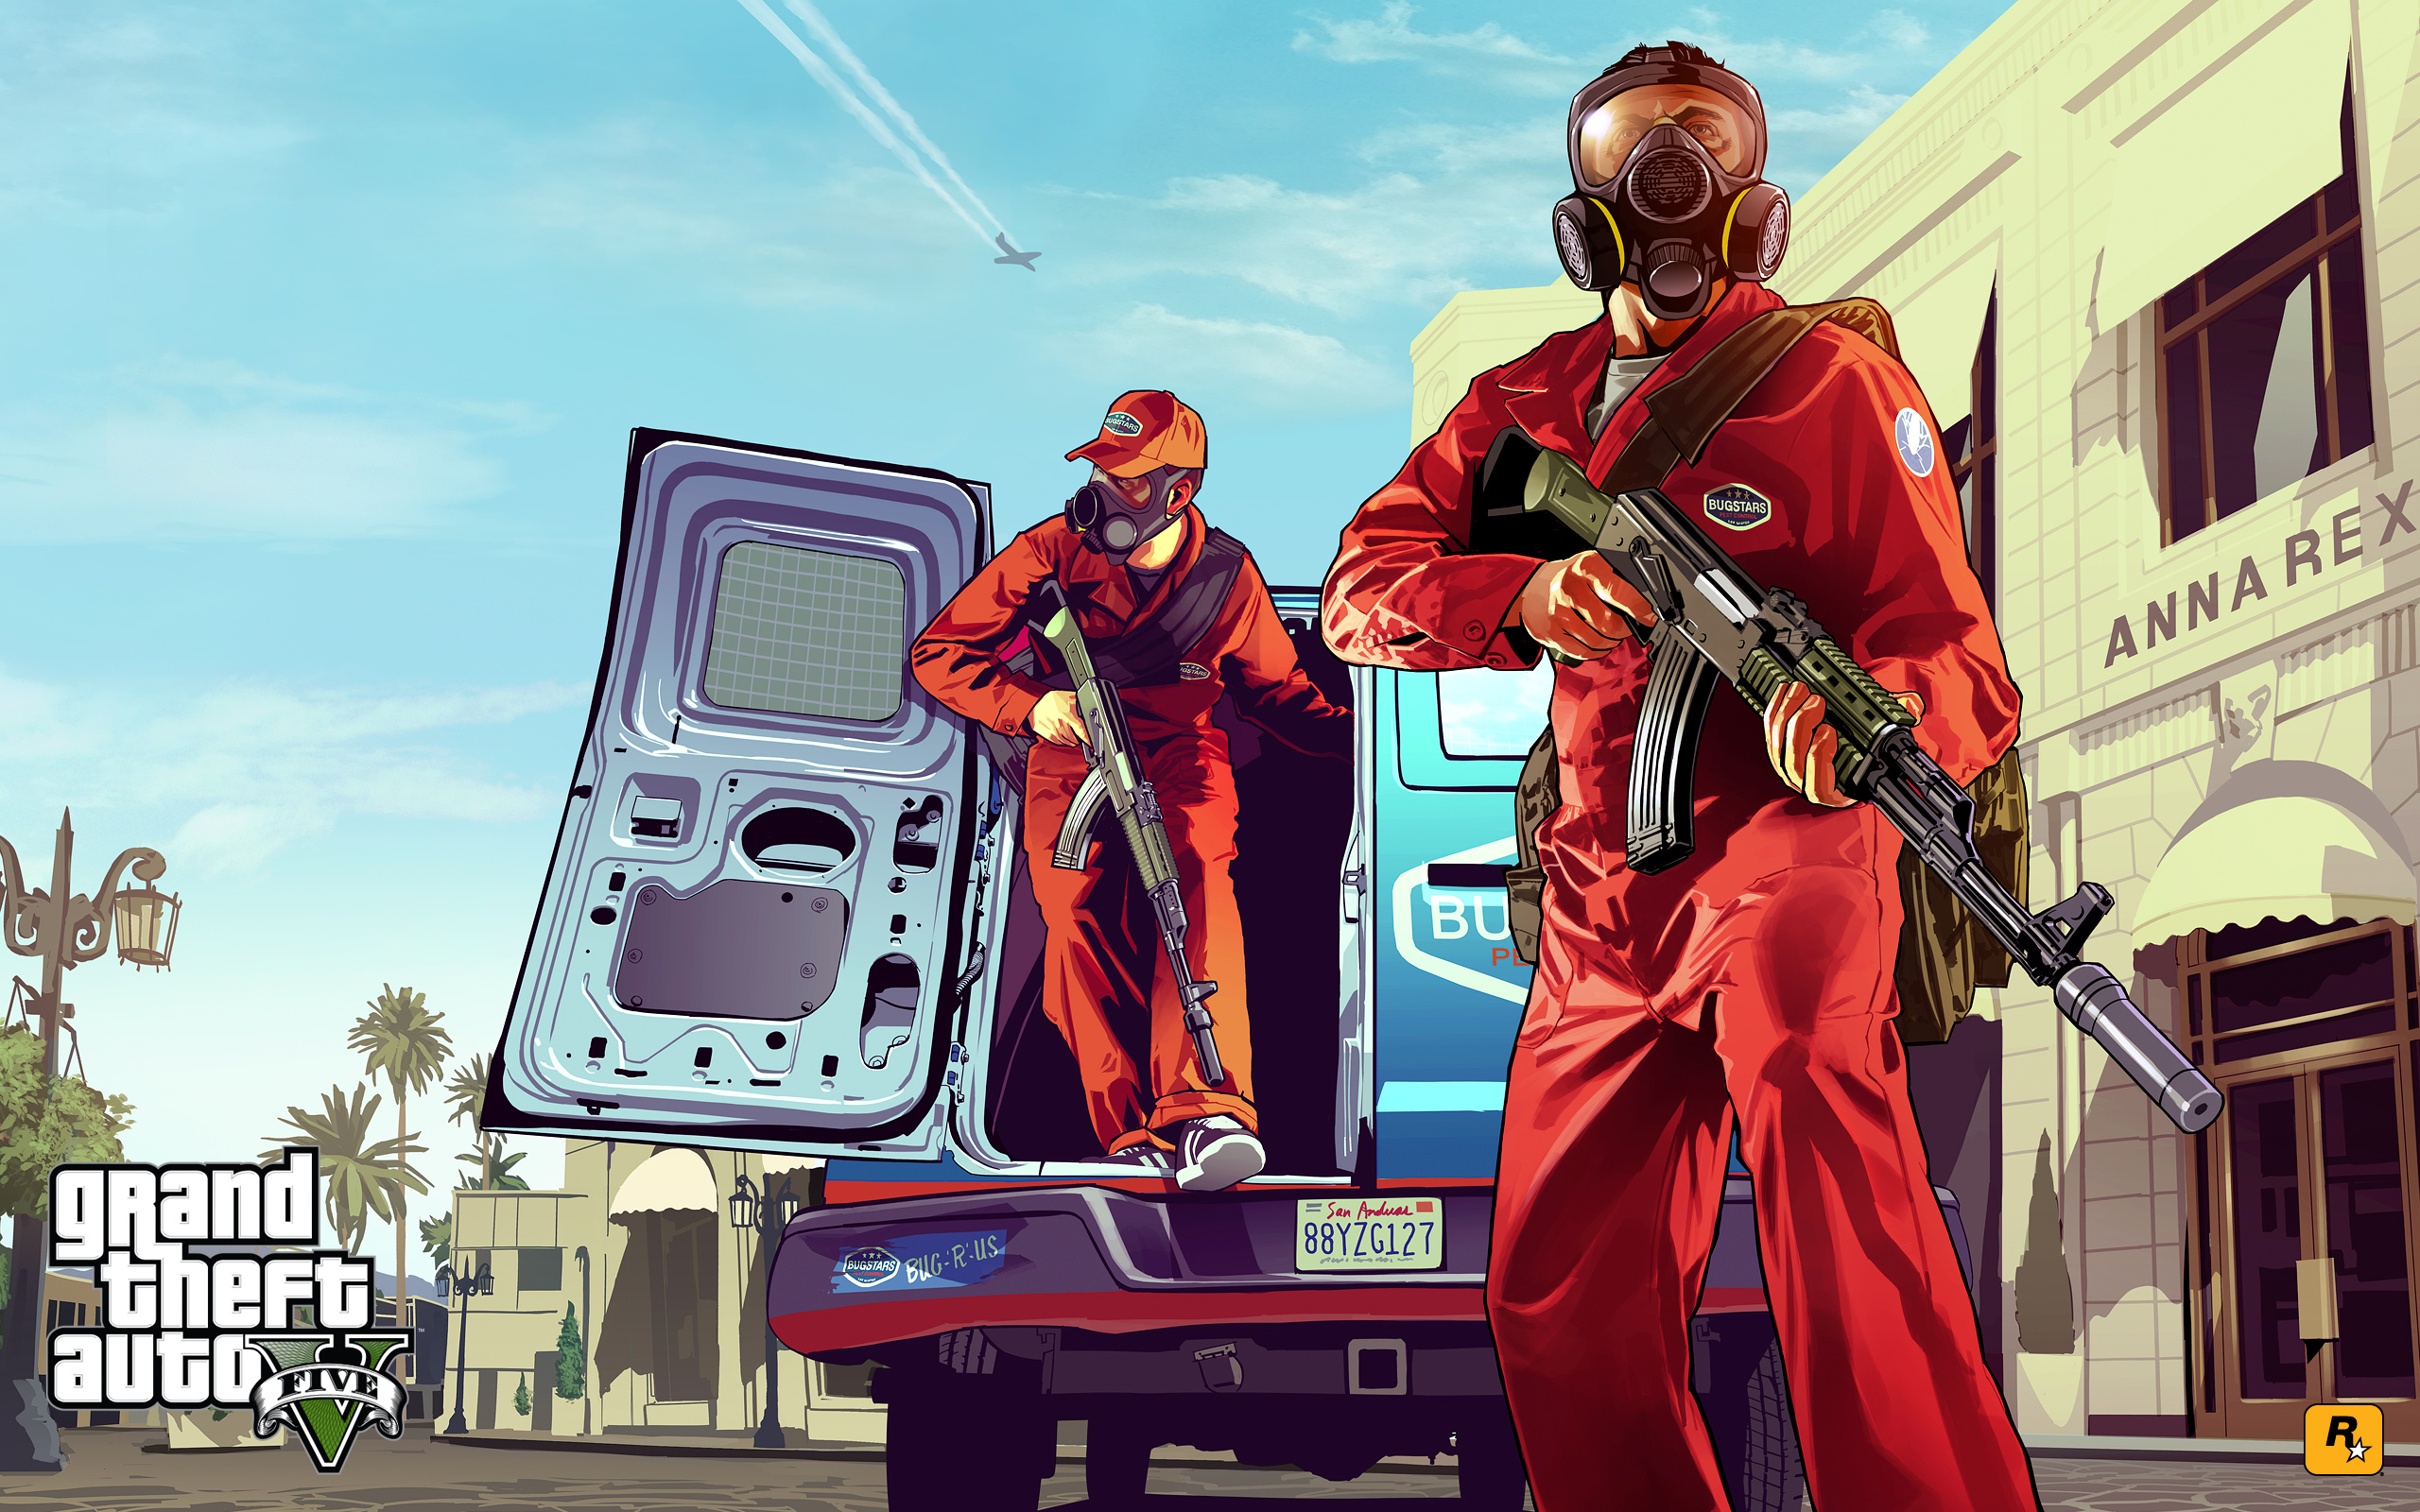

We can take a look at the things that make a normal heist or player vs. a gang mission work. To begin, in a heist the player must choose how they would like to handle the mission and the AI players that will join you on this mission. This is where you will control the AI that will be on your side for the mission. Each character has stats, some are better than most. The character you choose can greatly affect how well or bad a mission will go.

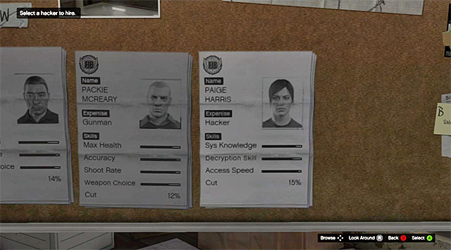

Now before we move into the mission, the image above shows 3 characters that the player chooses to join them on the mission. Each class had about 3 or 4 options and all ranged differently in skills and cut from the heist. The player chose the best of all classes but suffered the cost of their services. I believe that the way Rockstar programmed the different players AI personalities was with the use of fuzzy logic. All the players are capable of doing the same thing but the fuzzy logic will help determine just how good they are and how they will react to a given scenario. For example, when I did this mission, I chose the second tier gunman who wasn’t that good at driving. I didn’t think it was necessary. When the cops chased us, he fell off his bike and we lost a big chunk of money. Granted we didn’t have to pay him.

With that being said we get into the grit of the mission. One of characters you choose is a programmer. That character’s main goal is to buy you as much time as possible while you rob the jewelry store. And that is literally all that the player is capable of. The program for this player has to be a basic finite state for each programmer that gives each one a set amount of time for robbery. Below is a basic state machine that could hold that time.

void state_machine()

{ first_state:

// Do some stuff here

switch(some_var) {

case 0:

goto first_state;

case 1:

goto second_state;

default:

return;

}

The next two characters you choose have a real affect on success of the mission and the amount you take home. Both characters are gunman and have 4 different stats you need to pay attention to and consider. The stats are max health, shoot rate, accuracy, and weapon of choice. These can range a bit so with that in mind, I think fuzzy logic was used. A break down will make it clear why this would be the choice.

* Max health – delegates the amount of health points the AI character has during the mission.
* Shoot rate- this should delegate how long the character will shoot and how long the breaks are in between fires
* Accuracy – this figures out the ratio at which the AI will hit the enemy players when firing at them.
* Weapon of choice – the figures the size and power of the weapon. This can range from a very basic pistol to a fully equipped machine rifle.

If I estimate correctly with the max health, this doesn’t mean that one character starts off with 50% health while others start off with 90%. I believe that all of the characters have 100% health and the additional percentage of body armor is what you are choosing. So this the fuzzy logic of this would range from 30%- 90% and the amount associated with the character will add onto the health meter. The shoot rate should have two states that it follows the time that it fires and the delay time in between fires. The accuracy state in the fuzzy logic is probably a percentage number that works into a ratio formula for how often bullets land. And then the weapons choice state should land on a certain weapon if the percentage is within a given section.

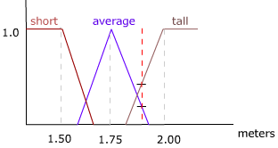

Due to the haste of the mission, all characters are using a seek movement algorithm. In the jewelry store, the AI characters run straight to the nearest cases and clear them out and then move on to the next one. Once that is completed, everyone moves towards the truck to leave. The cops are called and all players must race to a meeting point in a field. The difference is that the way to get there isn’t at all the fastest way to get there and you must travel through the sewers to evade cops. The characters follow a driving line to the meeting spot and the player is basically tasked to keep up with these AI characters. Once everyone has reached the “goal” zone, the mission is completed and is considered a success.

